**Course Work Answer Book**

**UNIVERSITY COURSE WORK**

|  |  |  |  |  |  |  |  |  |  |  |  |  |  |  |  |
| --- | --- | --- | --- | --- | --- | --- | --- | --- | --- | --- | --- | --- | --- | --- | --- |
| REGISTRATION NUMBER | | | | | | | | | VU-BIT-2301-0320-DAY | | | | | | |
| Title of The Program (eg BBA, BSC, BPH, BSWA) | | | | | | | | | | | | | BIT | | |
| Bachelor of Information Technology | | | | | | | | | | | | | | | |
| Department | | | | Other Depts in Faculty of Science and Technology | | | | | | | | | | | |
| Faculty | Faculty of Science and Technology | | | | | | | | | | | | | | |
| Year Of study (YrI , YrII, YrIII, or YrIV) | | | | | | | | | | | 2 | | | | |
| Module Code and Name | | | | | | | 2211 FST | | | | | | | | |
| Systems Administration | | | | | | | | | | | | | | | |
| Semester | | | 2 | | | | | | | | | | | | |
|  | | | | | | | | | | | | | | | |
| Retake: | | Yes | | |  | | | No | |  | | (Tick whichever is applicable) | | | |
| Date of Course Work | | | | | | Tue Jul 30 2024 00:00:00 GMT+0300 (East Africa Time) | | | | | | | | | |
|  | | | | | |  | | | | | | | | | |
| **DIRECTIONS TO CANDIDATES (Turn to page ii for more instructions).** | | | | | | | | | | | | | **FOR USE BY EXAMINERS ONLY** | | |
| **Question Number** | **Internal Examiner** | **External Examiner** |
| 1. Leave margin blank. 2. Begin each answer on a fresh page. 3. Write the number of each question and theCandidate's Number at the top of each page. 4. Write the numbers of the questionswhich you have attempted, with subsections where necessary, in the spacesprovided below | | | | | | | | | | | | |
|  |  |  |
|  |  |  |
|  |  |  |
|  |  |  |
|  |  |  |
|  |  |  |
|  |  |  |
|  |  |  |
|  |  |  |
|  |  |  |
|  |  |  |
|  |  |  |
|  |  |  |
|  |  |  |
|  |  |  |
| **TOTAL** |  |  |

|  |  |  |  |  |  |  |  |  |
| --- | --- | --- | --- | --- | --- | --- | --- | --- |
| **NUMBER OF QUESTIONS** you have answered in the order in which you have written them | | | | | | | | |
|  |  |  |  |  |  |  |  |  |

**How and where should I submit my Course Work script?**

Every student will be required to submit their Course Work via [VClass Students Portal](https://vclass.ac/) E.g. you go to [www.vclass.ac](http://www.vclass.ac) and login, to your account, then on the left sidebar menu **click on Course Work**.

Under Course Work you will see the following: -

1. Instructions for that particular Course Work with time required to finish your Course Work as per instructions,
2. A student will be required to download the question paper and the answer sheet provided by the university within the same module Course Work, or a student can be required to attempt structured questions within the system depending on how the Course Work was set.
3. Submission of answered questions is done,
4. Student is required to click to **consent** to show that the answered Course Work belongs to them.
5. **Note** that if Course Work is for download, a student will be required to download the question paper and answer sheet, do their Course Work within the given stipulated time.
6. Required to scan and upload back the answered booklet through the same portal as per format available.
7. Course Work uploaded will directly be received by the Registry department.
8. Students here are required to use [VClass e-Learning system](https://vclass.ac)for all Course Work and for any failure they can contact the Registry department for guidance.
9. No late submission will be accepted.

**Avoid any malpractice because this will attract severe penalties such as invalidating the answered script whose consequences will attract retakes.**

**Question One**

**Based on this case, what way could have been used to manage risk, system complexity, and system scale?**

* **Paper work:** Mr. Godwin's confusion over the "port" parameter highlights the importance of clear paper work. A good detailed paper work would have helped him understand the configuration settings better, preventing the error.
* **Protocols:** Having protocols for setting up servers and configuring networks would have helped avoid the misconfiguration. Protocols ensure that team members follow the same best practices.
* **Collaboration Tools:** Using collaborative tools that allow for real-time communication would have significantly improved the troubleshooting process. This would have allowed the team to share information and work together more easily.
* **Training:** Providing enough training on system configurations, especially for new technologies, can help reduce misunderstandings and errors.

**What problem can you identify with available systems administration tools?**

* The case shows a problem with the lack of clear understanding in system administration tools. The uncertainty of the "port" parameter contributed to the misunderstanding.

**From the case, Mr. Godwin was assigned to create a new web server on a machine outside the corporate firewall. He also misunderstood the meaning of a certain configuration parameter. As a systems administrator, discuss three (3) critical issues that could be considered in maintaining systems in such an organization.**

* **Security:** Having systems outside the corporate firewall introduces security risks. Proper security measures, such as firewalls, interruption detection systems, and regular security reviews are essential.
* **Access Control:** Controlling access to the web server is crucial. Implementing strong password policies, role-based access control, and logging user activity can help prevent unauthorized access.
* **Monitoring:** Continuous monitoring of the web server is very important for detecting performance issues, and security breaches.

**As a systems administrator, based on your knowledge of workstations, identify four (4) benefits of managing machines correctly.**

* **Improved Performance:** Properly managed machines run efficiently, minimizing downtime and maximizing productivity.
* **Enhanced Security:** Correctly configured machines are less vulnerable to malware and security threats.
* **Reduced Costs:** Effective machine management helps reduce IT support costs by minimizing issues and troubleshooting time.
* **Data Integrity:** Properly managed machines ensure data integrity and prevent data loss.

**Mr. Godwin misunderstood the meaning of a certain configuration parameter for the new web server (ambiguously labeled as "port"). Given your knowledge of namespace, state one (1) method for selecting namespaces correctly.**

* **Standardization:** Implementing a standard naming convention for namespaces can help avoid confusion. For instance, using clear and descriptive prefixes or suffixes for namespaces related to specific functionalities or servers can make it easier to identify and differentiate them.

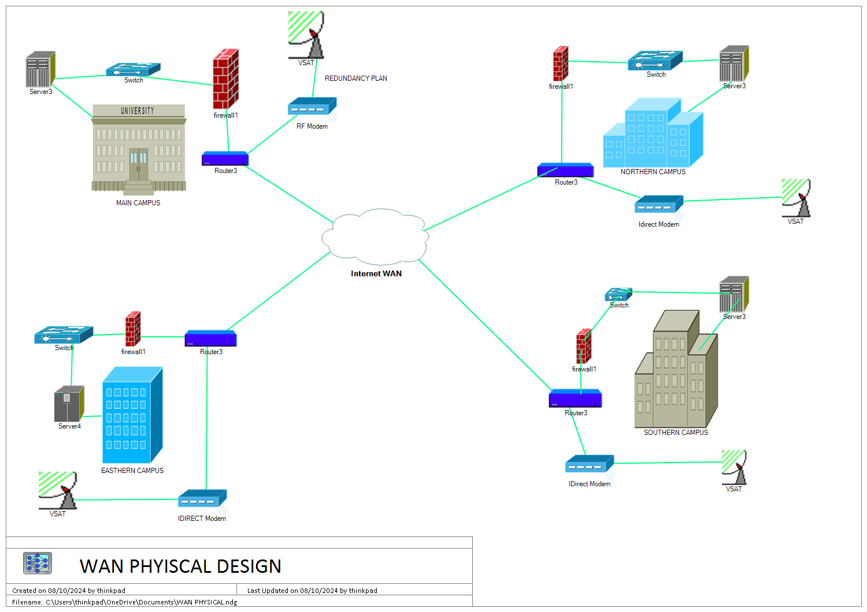

Below are several factors that need to be taken into account when Considering WAN

* Performance: The WAN solution should provide high-speed and reliable connectivity to facilitate seamless communication and data sharing between all campuses
* Security: Security is a critical concern for any WAN solution, particularly in a university environment, where sensitive data is stored and shared. The WAN solution should be secure enough to prevent unauthorized access, data breaches, hacks, and malware attacks.
* Scalability and expandability: It is important to choose a WAN solution that is scalable and can handle future network growth. The university should plan for expansion and growth in the number of users, applications, and data, and choose a WAN solution that can accommodate these changes.
* Support: The WAN solution should have good support and customer service, with dedicated technical support available to resolve any issues that may arise. The university should choose a WAN solution that provides technical support 24/7, with quick response times and resolutions.

**Private WAN (leased lines or MPLS) and a Public WAN (Internet)**

**Private WAN PROS**

* Dedicated and secure network: A private WAN provides a dedicated and secure network for the university, which can help to ensure the confidentiality, integrity, and availability of its data and applications.
* Cost-effective long-term solution: A private WAN can be a cost-effective solution in the long term, particularly if the university has multiple campuses and requires a high-bandwidth network to efficiently connect them.
* Control over network configuration: With a private WAN, the university has complete control over the network configuration, which can be an advantage in terms of security and management.
  + **CONS**
* Limited flexibility: A private WAN can be less flexible than a public WAN, as the university can be limited in its ability to choose different providers or network configurations.
* Limited scalability: A private WAN can be less scalable than a public WAN, as it can be difficult to add new users or applications to the network.

**Public (Internet) PROS**

* Affordable: The cost of using the internet as a WAN solution can be significantly lower than using a private WAN, as it does not require the cost of dedicated lines or MPLS networks.
* Scalable: The internet can be highly scalable, as it can be easy to add new users or applications to the network.
* Flexible: The internet can be highly flexible, as the university can choose from a variety of different providers and network configurations.
* Rapid

WAN TECHNOLOGY and WHY?

* A public WAN can be much more cost-effective than a private WAN, particularly for universities with a limited budget.
* With a public WAN, the university can pay a flat rate or per-use fee for internet access, which can be more affordable than dedicated lines or MPLS network connections.
* Public WANs can be highly scalable, as it is easy to add new users or applications to the network. Universities can quickly and easily increase their network capacity to meet the needs of their growing student population or as new applications and services are implemented.
* Finally, public WANs can provide the university with more flexibility compared to a private WAN. With a public WAN, the university can choose from a variety of different providers and network configurations to find the best fit for their unique needs and budget.





There are several factors that need to be considered when selecting the appropriate technology for Victoria University's computer lab.

* **Hardware:** The first factor to consider is the hardware needed for the computer lab. The amount of power and memory required will depend on the applications and workloads that will be running on the computers. The cost and reliability of the hardware, as well as the ability to upgrade and maintain it over time.
* **Software**: The choice of software is also an important consideration. The software should be compatible with the hardware and have the necessary features and functionality to meet the needs of the users
* **Networking**: The computer lab will also require a reliable and secure network, which can be used to connect computers, printers, and other devices. a network solution that is scalable, secure, and offers high-speed connectivity.
* **Maintenance**: The computer lab will require regular maintenance to ensure that the hardware and software are working properly and to prevent breakdowns. The maintenance should include regular backup, anti-virus software, and security updates to prevent malicious attacks.

Classless Inter-Domain Routing (CIDR)

* Flexible subnet sizes: Allows for creating subnets with arbitrary sizes using variable-length subnet masks (VLSM). This allows for efficient address allocation based on actual requirements.
* Address space optimization: Reduces wasted address space by creating subnets that are precisely sized for the connected devices.
* Hierarchical addressing: Enables hierarchical network structures by allowing for nesting of subnets within larger networks.
* Suitability for Victoria University
* For Victoria University's network, CIDR is the more suitable subnetting method. This is because:
* Flexibility: The University has diverse campuses with varying host requirements. CIDR allows creating subnets of different sizes for each campus, ensuring efficient address utilization.
* Scalability: As the university grows, CIDR allows easily creating smaller subnets to accommodate new devices without disrupting existing networks.
* Hierarchy: CIDR enables the creation of a hierarchical network structure by assigning different subnet masks to different campuses. This simplifies network management and allows for easier routing between campuses.

https://github.com/onenm072024/CW.git